MATJAŽ DEBEVEC, Ph.D.
ASSOCIATE PROFESSOR, FACULTY OF ELECTRICAL ENGINEERING AND COMPUTER SCIENCE, UNIVERSITY OF MARIBOR, SLOVENIA

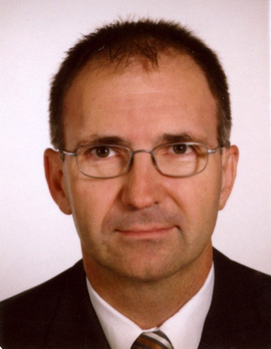

Dr. Matjaž Debevc, Associated Professor, received Ph.D. degrees in computer science from University of Maribor, Slovenia in 1995. Since 1999 until 2003 he has being founder and Head of the Centre for Distance Education Development at the University of Maribor and from 2006 visiting lecturer at the Carinthia University of Applied Sciences in Villach, Austria. From 2010 till 2011 he was a visiting researcher at ETH, Zürich and at PHONAK, Stäfa, Switzerland.

His research interests include human-computer interaction, e-learning, visual communication and accessibility. He participated as leader and partner in more than 70 EU and national research and development projects.

He published more than 400 articles, papers, books and publications for scientific journals and conferences. He has (co-)organized, chaired or served as a programme committee
member for several international events, also serving as a reviewer for several scientific
journals and for European research agency. Dr. Debevc was a general chairman of IEEE Education Society Chapter in Slovenia and a member of ACM. Since 2016 he is a member of the Expert Group on the Accessibility at World Federation of the Deaf (WFD).

