MARK LAUREYNS
AMPLIFON CENTRE FOR RESEARCH AND STUDIES
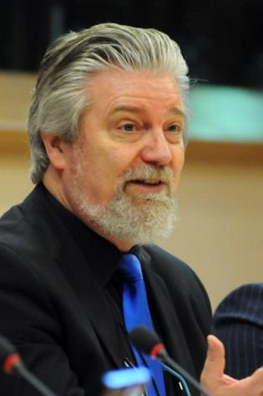
Mark Laureyns is Audiologist and Speech Pathologist, he is director of the International CRS (Amplifon Centre for Research and Studies) in Milan, he lectures Hearing Aid Fitting at the Thomas More University College, Department of Audiology in Antwerp and since 2014 he is president of the AEA (European Association of Hearing Aid Professionals). His field of research concerns, the added value of hearing aid signal processing, central auditory processing, localization and binaural masking release, the relation between hearing and cognition, the relation between diabetes and hearing loss and quality professional hearing care.
He was born in September 1960, graduated as speech pathologist in 1982, he received his degree as rehabilitative audiologist in 1983 and graduated in hearing science in 1997. He started as speech pathologist at the Antwerp institute for hard of hearing children in 1983 he started working as a rehabilitative audiologist for L’Acoustique Médical in Belgium in 1983. Since 1997 he has the position as lecturer hearing aid fitting at the Thomas More University College in Antwerp and since 2012 he is heading the Amplifon Centre for Research and Studies in Milan.
He has been vice president of the Belgian National Association of Hearing Aid Professionals (CEUPA) since 1992, he joined the AEA (European Association of Hearing Aid Professionals) technical workgroup in 2009 and was elected AEA president in 2014. EFHOH (European Federation of Hard of Hearing People) is a very strong partner for AEA, we value the principle of “Nothing About Us Without Us”, and we walk the talk. In all new regulatory initiatives, new and updated standards, the code of conduct and the relation with international association and stakeholders, EFHOH is always fully involved and consulted, to ensure that what we do is certainly also in the interest of the users.

